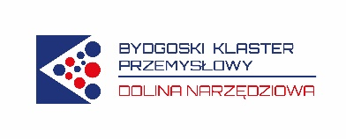

We are pleased to announce that as a result of many years of cooperation between Lenso sp. z o.o. and Kaplast sp. z o.o. from March 1, 2022, we are introducing joint services for the tooling and processing industry, provided as part of the Bydgoszcz Industrial Cluster Dolina Narzędziowa.
- Specialized measurement training
Using many years of experience and professional practice of employees of both companies in the tool and processing industry, we offer you training tailored to the individual needs of the interested parties. They can cover any level of advancement. We also conduct training in English.
Example topics:
- 3D measurements with optical scanners in quality control and dimensional analysis using the GOM INSPECT program
- Reverse engineering from detail to model
- Metrological training in the field of dimensional control of length and angle as well as GD&T characteristics using the GOM Inspect software
- Basics of technical drawing and data analysis using GOM Inspect software
Trainings are held in the conference rooms of Kaplast sp. z o.o., Lenso sp. z o.o. and Cluster.
- Specjalistyczne usługi pomiarowe
The services will be provided by qualified specialists from both companies using the following devices:
- Atos ScanBox series 4 – optical measuring system
- KEYENCE IM-700 – digital measuring projector
- Wenzel Xorbit XO55 – 3D coordinate measuring machine
- altimeter, thickness gauge, hardness gauge, spectrophotometer, measuring rollers and plates, calipers and others.
Services take place in the laboratories of Kaplast sp. z o.o. and Lenso sp. z o.o.
Anyone interested in the details of services, please contact the office of the Bydgoszcz Industrial Cluster Dolina Narzędziowa, which is their coordinator (tel. 52 515 30 73, e-mail: bkp@klaster.bydgoszcz.pl).

